***Tech – Savvy or Not, Must Know Trending Technologies to Stay Relevant***

## Introduction

In today's fast-paced world, staying up to date with technology is more important than ever. Whether you consider yourself tech-savvy or not, it is crucial to have a basic understanding of trending technologies to stay relevant in various aspects of life. Contrary to popular belief, being tech-savvy is not limited to experts or professionals in the field. This article aims to highlight the necessity of staying informed about emerging technologies and their impact on society at large.

## Understanding the Importance of Technology

Technology has seamlessly integrated itself into our daily lives, revolutionizing the way we communicate, work, and live. From smartphones to smart homes, technology has become an integral part of our existence. Understanding and leveraging this technology is paramount to effectively navigate the modern world. Furthermore, technology has also transformed various industries and professions, ranging from healthcare to finance. Having a grasp on the technological advancements relevant to your field can enhance productivity and streamline processes.

## The Accelerating Pace of Technological Advancements

Technological advancements are progressing at an accelerating rate, constantly introducing new tools, platforms, and possibilities. It is crucial to stay aware of these advancements to remain competitive in the job market. Being knowledgeable about new technologies opens doors to career growth and better opportunities. In the rapid evolution of technology, those who are well-versed in the latest trends have an edge over those who lag behind.

## Artificial Intelligence and Machine Learning

Artificial Intelligence (AI) and Machine Learning (ML) are rapidly transforming various industries. AI refers to the development of intelligent machines that can perform tasks that typically require human intelligence. Machine Learning, on the other hand, is a subset of AI that focuses on enabling machines to learn from data and improve their performance over time. These technologies have the potential to revolutionize healthcare, finance, transportation, and many other sectors. AI and ML can automate processes, improve efficiency, and provide valuable insights from significant amounts of data.



## Internet of Things (IoT)

The Internet of Things (IoT) refers to the network of interconnected devices and sensors that collect and exchange data over the internet. IoT enables the seamless integration of data and information from various sources, allowing for real-time monitoring, control, and automation. The potential of IoT extends beyond the realm of personal convenience, as it also impacts industries such as manufacturing, agriculture, and energy management. By harnessing the power of IoT, businesses can optimize processes, improve decision-making, and enhance overall productivity.



## Blockchain Technology

Blockchain technology, most commonly associated with cryptocurrencies like Bitcoin, has far-reaching applications beyond the realm of finance. At its core, blockchain is a decentralized and transparent digital ledger that records transactions across multiple computers. It provides a secure and immutable record of information, which is particularly valuable in industries such as supply chain management, healthcare, and even voting systems. The potential advantages of blockchain include enhanced security, improved transparency, and reduced intermediaries.



## Big Data and Analytics

Big data refers to the vast amount of structured and unstructured data that is generated on a daily basis. Businesses can harness the power of big data by using analytics tools and techniques to extract meaningful insights and make data-driven decisions. The ability to analyse and interpret large datasets can revolutionize organizations and industries, providing valuable insights for marketing strategies, customer behaviour analysis, and risk assessment, among many other applications.



## Virtual Reality (VR) and Augmented Reality (AR)

Virtual Reality (VR) and Augmented Reality (AR) are immersive technologies that are transforming industries such as gaming, entertainment, and education. VR creates a simulated environment, whereas AR overlays virtual elements onto the real world. These technologies have vast potential in industries such as architecture, healthcare, and training. VR and AR can enhance visualization, training, and interactive experiences, creating new possibilities for enhanced user engagement and learning.



## Cybersecurity and Data Privacy

In an increasingly digitized world, the importance of cybersecurity and data privacy cannot be overstated. With the growing prevalence of cyber threats and data breaches, individuals and organizations must prioritize securing their sensitive information. Common cybersecurity threats include phishing attacks, malware, ransomware, and social engineering. It is crucial to stay vigilant and implement robust security measures to protect personal and sensitive data.



## Automation and Robotics

Automation and robotics have had a profound impact on various industries, from manufacturing to healthcare. These technologies aim to automate repetitive tasks, improve efficiency, and reduce human error. While automation and robotics may replace certain job functions, they also create opportunities for upskilling and the development of new roles. Embracing automation and robotics can revolutionize industries, improve productivity, and enhance overall economic growth.

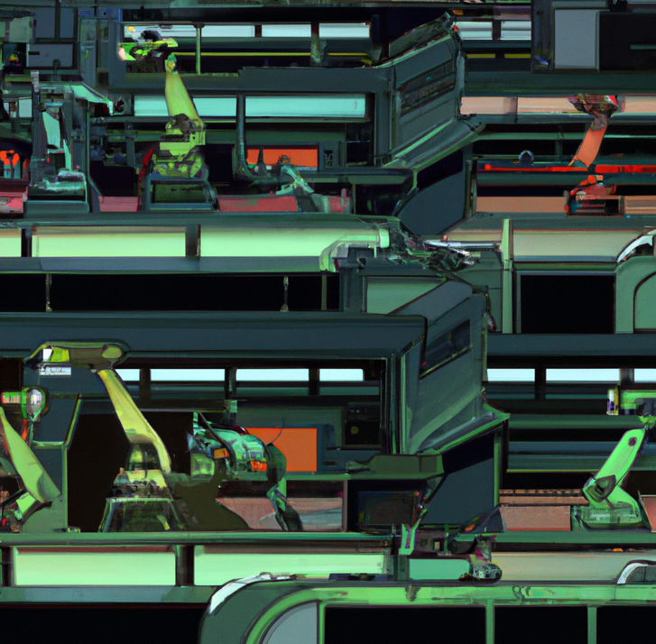

## Cloud Computing

Cloud computing involves the delivery of computing services, including storage, databases, software, and analytics, over the internet. This technology allows individuals and businesses to access and store data remotely, providing flexibility and scalability. Cloud computing has become the foundation of numerous digital services, enabling collaboration, data backup, and seamless access to resources. Its significance spans across industries such as e-commerce, healthcare, and finance.



## 5G and the Future of Connectivity

The fifth generation of wireless technology, or 5G, promises faster download and upload speeds, lower latency, and enhanced connectivity. This advancement has the potential to revolutionize industries such as autonomous vehicles, smart cities, and telemedicine. 5G technology enables faster and more efficient data transmission, paving the way for innovative applications and services that rely on real-time data transfer. The future with 5G is poised to connect people, devices, and industries like never before.



## Quantum Computing

Quantum computing is an emerging field that harnesses the principles of quantum mechanics to perform complex calculations. Unlike classical computers, which use bits to represent information, quantum computers use qubits, which can exist in multiple states simultaneously. Quantum computing has the potential to solve problems that are currently unfeasible for classical computers whilst also having applications in fields such as cryptography, optimization, and drug discovery.

To put it into perspective, a quantum computer solved a problem in under 4 minutes which would take a normal computer thousands of years.



## Mobility and Autonomous Innovations

The advancements in autonomous vehicles and transportation technology are reshaping the future of transportation systems. Using sensors, artificial intelligence, and machine learning, vehicles can operate without direct human intervention. Autonomous technology has the potential to improve road safety, reduce congestion, and enhance transportation efficiency. Pioneers in the field such as: Tesla, BMW and Mercedes are leading the charge with self-driving capabilities and automated parking systems. Additionally, next-generation vehicles, such as electric and hydrogen-powered cars, contribute to sustainability efforts by reducing carbon emissions.



## Wearable Tech and Health Tech

Wearable technology has revolutionized the healthcare industry, enabling individuals to track their fitness, monitor vital signs, and manage chronic conditions. Wearable devices, such as smartwatches and fitness trackers, provide valuable insights into your health and wellness. Health tech also encompasses various technologies like telemedicine, electronic health records, and remote patient monitoring, which enhance accessibility and improve healthcare delivery. For instance, the Fitbit and Samsung’s Galaxy Watch provide numerous health features along with the Apple Watch where you can perform an ECG and alert you if your heart rhythm is irregular.



## Conclusion

Staying updated on trending technologies is essential for staying relevant and seizing new opportunities in today's rapidly evolving world. Whether you consider yourself tech-savvy or not, having a basic understanding of emerging technologies is crucial for personal and professional growth. The advantages and opportunities that come with familiarity in trending technologies are vast. The discussed technological trends above are just a glimpse of the dynamic landscape shaping our world. Emerging fields such as technology in education, represented by innovations like ChatGPT, and transformative breakthroughs in biotechnology and genetic engineering further exemplify the vast array of advancements that continue to drive our society forward. By embracing new technologies and continuously learning, individuals can stay ahead of the curve and adapt to the constant changes shaping our society.

## FAQs (Frequently Asked Questions)

**Why is it important to stay knowledgeable about trending technologies?**

Staying knowledgeable about trending technologies is essential to remain relevant in various aspects of life, including personal and professional spheres. It enables individuals to navigate the modern world effectively and seize new opportunities.

**How can one start learning about these technologies if they have no prior knowledge?**

Starting to learn about these technologies is as simple as exploring online resources, attending webinars or workshops, and engaging in communities dedicated to discussing technology trends. Beginner-friendly tutorials and courses are also available to help individuals get started.

**Are these technologies only relevant for certain industries?**

No, these technologies have a wide range of applications across industries. From healthcare to finance, education to transportation, technology is transforming various sectors. The impact and relevance of these technologies extend beyond specific industries.

**Is it possible to stay relevant without being tech-savvy?**

While being tech-savvy certainly has its advantages, staying relevant can still be achieved without being an expert. Having a basic understanding of emerging technologies and their potential impact is crucial.

**What resources are available for individuals to keep up with new technologies?**

There are numerous resources to help individuals keep up with new technologies, including online publications, tech blogs, industry-specific forums, and social media platforms dedicated to discussing technology trends. Additionally, online courses and webinars provide structured learning opportunities.

**How often do new technologies emerge and become significant?**

New technologies emerge at a rapid pace, with advancements occurring year-round. The significance of these technologies varies, but staying aware of emerging trends ensures that individuals can adapt to the ever-changing landscape.